重庆科技学院

上机实验报告(程序设计类)

|  |  |  |  |  |  |  |
| --- | --- | --- | --- | --- | --- | --- |
| 课程名称 | 面向对象的序设计方法 | | 实验题目 | Java图形界面 | | |
| 机房编号 | I301 | | 上机时间 | 2018-11-26 | | |
| 指导老师 | 王双明 | | 报告序号 | 5 | 上机成绩 | . |
| 学生姓名 | 袁阊越 | 学号 | 2018520612 | 教学班级 | 计科升2016 | |
| **一、上机目的和要求:**  1. 掌握常用容器的使用方法；  2. 掌握AWT事件处理机制；  3. 掌握常用事件，如动作事件、焦点事件、鼠标事件、键盘事件等的使用；  4. 掌握常见布局管理器的用法，如FlowLayout,、BorderLayout、GridLayout等；  5. 掌握常用面板的用法，如JPanel、JScrollPane等的使用；  6. 掌握常用组件的用法，如JButton、JLabel、JTextField、JPasswordField的使用。 | | | | | | |
| **二、程序开发环境:**  处理器：Intel(R) Core(TM) i7-3770 CPU @ 3.40GHz (8 CPUs), ~3.4GHz  操作系统：Windows 7 专业版 32-bit  内存：4GB  JDK：jdk1.6.0_04  软件：eclipse | | | | | | |
| **三、上机内容(老师布置的具体任务):**  1. 编写一个应用程序，有一个标题为“登录”的窗口，能实现用户名和密码的输入。  （1）如果用户名和密码输入正确，则单击“登录”按钮弹出“用户登录成功”的消息框；  （2）如果用户名和密码输入错误，则单击“登录”按钮弹出“用户登录失败”的消息框。  2. 参考下图，设计一个简单的加法计算器。单击“=”按钮，做加法运算，把计算结果显示在文本框中。    3. 编写一个应用程序，有一个标题为“注册学生信息”的窗口，窗口的布局和组件请自行设计，能实现学生信息的注册功能。  （1）其中学生信息包括：学号、姓名、出生日期等；  （2）单击注册按钮，如果未注册过则弹出“学生信息注册成功”的对话框，并把学生添加到List集合中；  （3）单击注册按钮，如果学生已经注册过，则弹出“学生信息已存在，注册失败”的对话框；  （4）单击取消按钮，结束本次注册并关闭窗口。  （5）采用面向对象程序设计思想  4.设计如下图所示的聊天窗口，实现以下功能：    （1）单击“发送”按钮，JTextField区域中的信息发送到聊天区，并清空其中的内容；  （2）窗口启动时，加载历史聊天记录；  （3）单击关闭按钮，保存聊天记录到文件，并关闭窗口。  5.请参照下图所示windows7附件中的标准计算器界面，设计一个计算器界面（菜单部分只需实现一级菜单即可）。    6.参见教材第238页，设计实现拼图游戏。（图片参考Koala.rar） | | | | | | |
| **四、上机调试中出现的错误信息、错误原因及解决办法:**  报错： 添加学生信息时候，信息重复  原因：点击事件触发后没有多余的判断  解决：对学生的list提前判断是否为空 | | | | | | |
| **五、上机实验中的收获及心得:**  在做Java图形界面的实验前，我以为不会难做，就像以前做物理实验一样，做完实验，然后两下子就将实验报告做完。直到做完测试实验时，我才明白其实并不容易做，但学到的知识与难度成正比，使我受益匪浅。  　　在做实验的过程中我还学会了掌握AWT事件处理机制，掌握常用事件，如动作事件、焦点事件、鼠标事件、键盘事件等的使用， 掌握常见布局管理器的用法，如FlowLayout,、BorderLayout、GridLayout等； 掌握常用面板的用法，如JPanel、JScrollPane等的使用；掌握常用组件的用法，如JButton、JLabel、JTextField、JPasswordField的使用。  　　透过这次Java图形界面的实验，使我学到了不少实用的知识，更重要的是，做实验的过程，思考问题的方法，这与做其他的实验是通用的，真正使我们受益匪浅。 | | | | | | |

建议：正文采用五宋体，代码用小五号Times new Roman字体

附录：

**一、程序流程图**

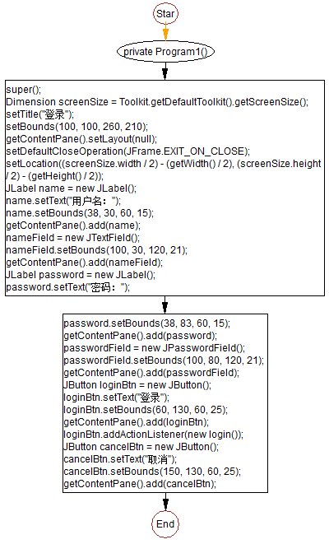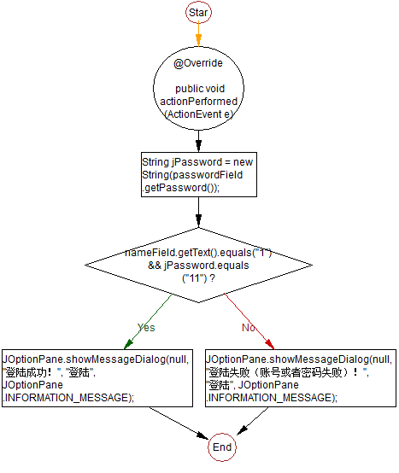

图1

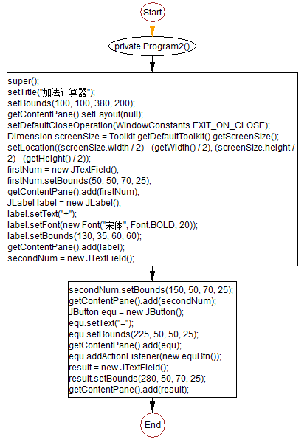

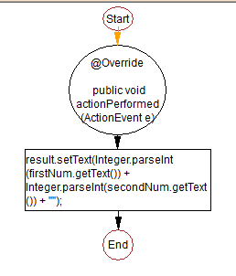

图2

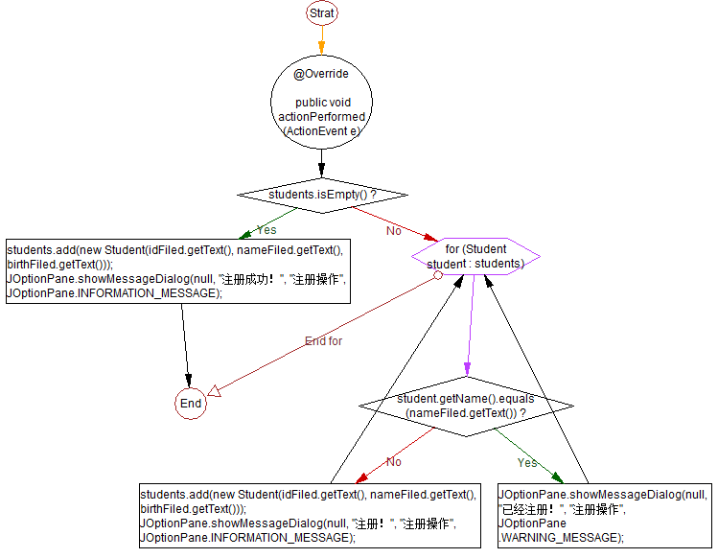

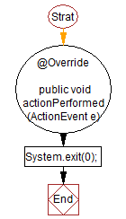

图3

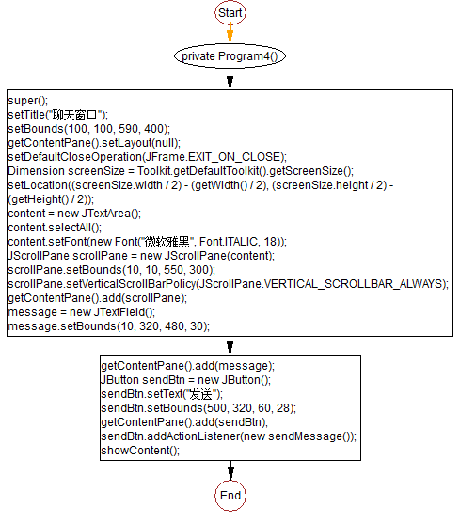

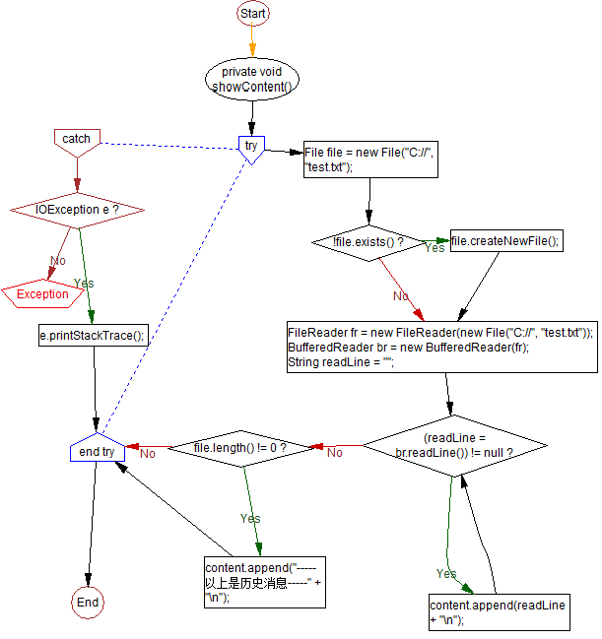

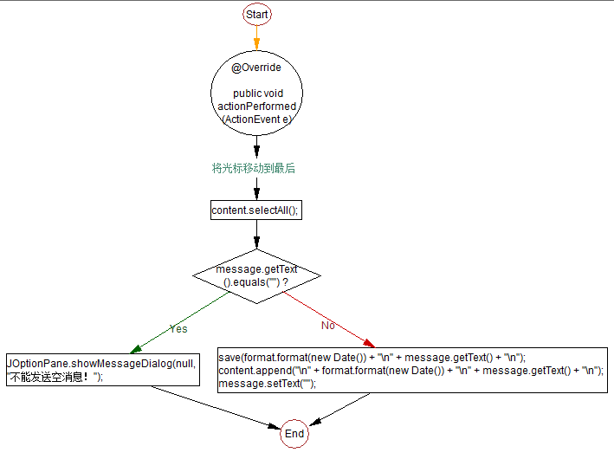

图4

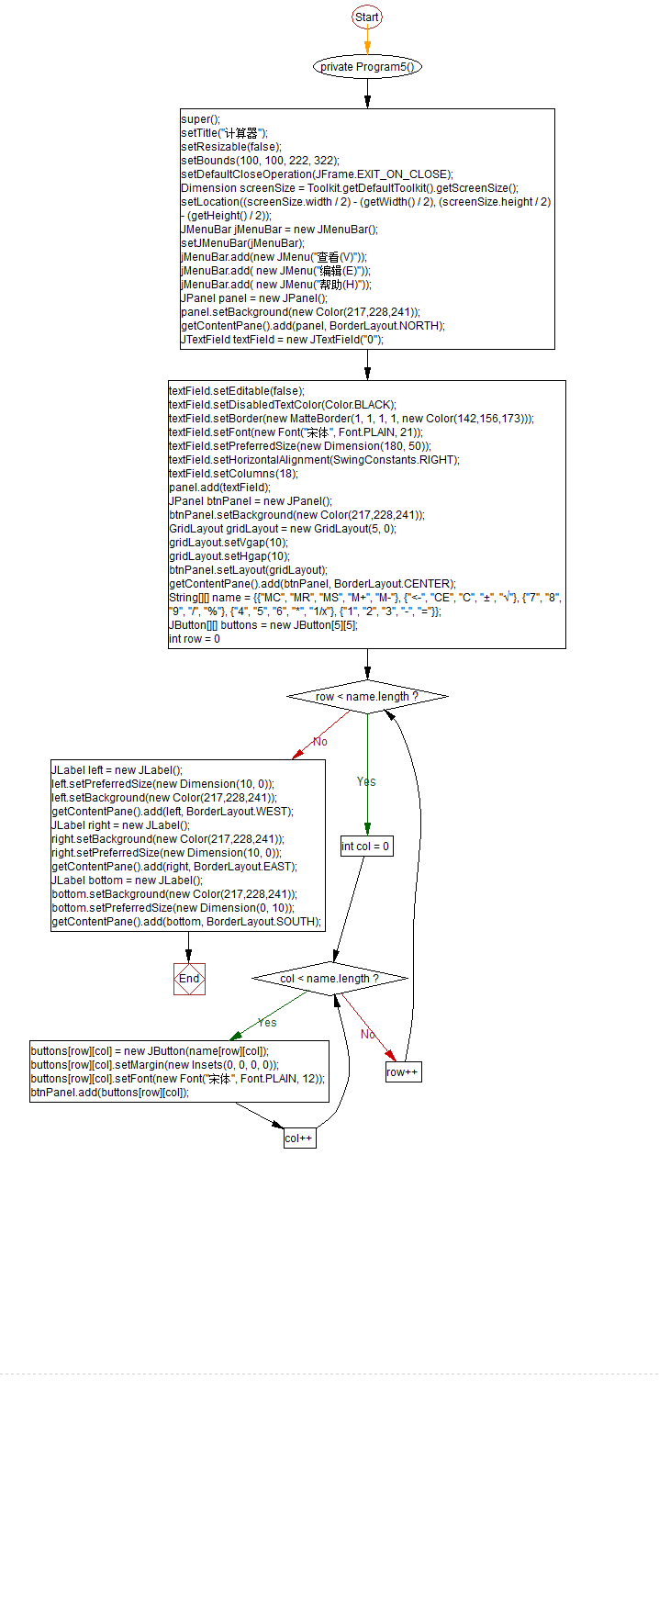

图5

**二、主要数据结构和变量说明**

第一题：

private final JTextField nameField;//姓名输入框

private final JPasswordField passwordField;//密码输入框

第二题：

private final JTextField firstNum; //第一个数字的输入框

private final JTextField secondNum; //第二个数字的输入框

private final JTextField result;//结果的输入框

第三题：

private final JTextField nameFiled; //姓名的输入框

private final JTextField idFiled;//ID的输入框

private final JTextField birthFiled; //出生日期的输入框

private LinkedList<Student> students = new LinkedList<>();//保存的注册的学生信息的liSt

第四题：

private final JTextField message;//要发送的内容

private final JTextArea content;// 显示的文本域

private SimpleDateFormat format = new SimpleDateFormat("YYYY-MM-dd HH:mm:ss");//格式日期

第五题：

final JPanel viewPanel = new JPanel(); // 创建显示器面板，采用默认的流布局

JTextField textField = new JTextField(); // 创建显示器

final JPanel buttonPanel = new JPanel(); // 创建按钮面板

final JLabel leftLabel = new JLabel(); // 创建左侧的占位标签

final JLabel rightLabel = new JLabel(); // 创建右侧的占位标签

第六题：

final JLabel modelLabel = new JLabel();// 创建显示参考图片的标签对象

final JPanel topPanel = new JPanel();// 创建面板对象

final JButton startButton = new JButton()// 创建“下一局”按钮对象

final JButton button = new JButton();// 创建拼图按钮对象

String[][] stochasticOrder = reorder();// 获得网格图片的随机摆放顺序

1. **上机调试后的源程序及注释**

**第一题**

package pers.ycy.test5;

import javax.swing.*;

import java.awt.*;

import java.awt.event.ActionEvent;

import java.awt.event.ActionListener;

public class Program1 extends JFrame {

private final JTextField nameField;

private final JPasswordField passwordField;

public static void main(String[] args) {

Program1 frame = new Program1();

frame.setVisible(true);

}

private Program1() {

super();

Dimension screenSize = Toolkit.getDefaultToolkit().getScreenSize();

setTitle("登录");

setBounds(100, 100, 260, 210);

getContentPane().setLayout(null);

setDefaultCloseOperation(JFrame.EXIT_ON_CLOSE);

setLocation((screenSize.width / 2) - (getWidth() / 2), (screenSize.height / 2) - (getHeight() / 2));

JLabel name = new JLabel();

name.setText("用户名：");

name.setBounds(38, 30, 60, 15);

getContentPane().add(name);

nameField = new JTextField();

nameField.setBounds(100, 30, 120, 21);

getContentPane().add(nameField);

JLabel password = new JLabel();

password.setText("密码：");

password.setBounds(38, 83, 60, 15);

getContentPane().add(password);

passwordField = new JPasswordField();

passwordField.setBounds(100, 80, 120, 21);

getContentPane().add(passwordField);

JButton loginBtn = new JButton();

loginBtn.setText("登录");

loginBtn.setBounds(60, 130, 60, 25);

getContentPane().add(loginBtn);

loginBtn.addActionListener(new login());

JButton cancelBtn = new JButton();

cancelBtn.setText("取消");

cancelBtn.setBounds(150, 130, 60, 25);

getContentPane().add(cancelBtn);

}

private class login implements ActionListener {

@Override

public void actionPerformed(ActionEvent e) {

String jPassword = new String(passwordField.getPassword());

if (nameField.getText().equals("1") && jPassword.equals("11")) {

JOptionPane.showMessageDialog(null, "登陆成功！", "登陆", JOptionPane.INFORMATION_MESSAGE);

} else {

JOptionPane.showMessageDialog(null, "登陆失败（账号或者密码失败）！", "登陆", JOptionPane.INFORMATION_MESSAGE);

}

}

}

}

**第二题**

package pers.ycy.test5;

import javax.swing.*;

import java.awt.*;

import java.awt.event.ActionEvent;

import java.awt.event.ActionListener;

public class Program2 extends JFrame {

private final JTextField firstNum;

private final JTextField secondNum;

private final JTextField result;

public static void main(String[] args) {

Program2 program2 = new Program2();

program2.setVisible(true);

}

private Program2() {

super();

setTitle("加法计算器");

setBounds(100, 100, 380, 200);

getContentPane().setLayout(null);

setDefaultCloseOperation(WindowConstants.EXIT_ON_CLOSE);

Dimension screenSize = Toolkit.getDefaultToolkit().getScreenSize();

setLocation((screenSize.width / 2) - (getWidth() / 2), (screenSize.height / 2) - (getHeight() / 2));

firstNum = new JTextField();

firstNum.setBounds(50, 50, 70, 25);

getContentPane().add(firstNum);

JLabel label = new JLabel();

label.setText("+");

label.setFont(new Font("宋体", Font.BOLD, 20));

label.setBounds(130, 35, 60, 60);

getContentPane().add(label);

secondNum = new JTextField();

secondNum.setBounds(150, 50, 70, 25);

getContentPane().add(secondNum);

JButton equ = new JButton();

equ.setText("=");

equ.setBounds(225, 50, 50, 25);

getContentPane().add(equ);

equ.addActionListener(new equBtn());

result = new JTextField();

result.setBounds(280, 50, 70, 25);

getContentPane().add(result);

}

private class equBtn implements ActionListener {

@Override

public void actionPerformed(ActionEvent e) {

result.setText(Integer.parseInt(firstNum.getText()) + Integer.parseInt(secondNum.getText()) + "");

}

}

}

**第三题**

package pers.ycy.test5;

import javax.swing.*;

import java.awt.*;

import java.awt.event.ActionEvent;

import java.awt.event.ActionListener;

import java.util.LinkedList;

public class Program3 extends JFrame {

private final JTextField nameFiled;

private final JTextField idFiled;

private final JTextField birthFiled;

private LinkedList<Student> students = new LinkedList<>();

public static void main(String[] args) {

Program3 program3 = new Program3();

program3.setVisible(true);

}

private Program3() {

super();

setTitle("注册学生信息");

getContentPane().setLayout(null);

setBounds(100, 100, 300, 300);

setDefaultCloseOperation(WindowConstants.EXIT_ON_CLOSE);

Dimension screenSize = Toolkit.getDefaultToolkit().getScreenSize();

setLocation((screenSize.width / 2) - (getWidth() / 2), (screenSize.height / 2) - (getHeight() / 2));

JLabel name = new JLabel("姓名：");

name.setFont(new Font("宋体", Font.BOLD, 20));

name.setBounds(80, 60, 100, 50);

getContentPane().add(name);

nameFiled = new JTextField();

nameFiled.setBounds(150, 75, 100, 25);

getContentPane().add(nameFiled);

JLabel label = new JLabel("学号：");

label.setFont(new Font("宋体", Font.BOLD, 20));

label.setBounds(80, 90, 100, 50);

getContentPane().add(label);

idFiled = new JTextField();

idFiled.setBounds(150, 105, 100, 25);

getContentPane().add(idFiled);

JLabel birth = new JLabel("出生日期：");

birth.setFont(new Font("宋体", Font.BOLD, 20));

birth.setBounds(40, 120, 150, 50);

getContentPane().add(birth);

birthFiled = new JTextField();

birthFiled.setBounds(150, 135, 100, 25);

getContentPane().add(birthFiled);

JButton register = new JButton();

register.setText("注册");

register.setBounds(50, 185, 70, 25);

getContentPane().add(register);

register.addActionListener(new registerListener());

JButton cancel = new JButton();

cancel.setText("取消");

cancel.setBounds(170, 185, 70, 25);

getContentPane().add(cancel);

cancel.addActionListener(new cancelListener());

}

private class registerListener implements ActionListener {

@Override

public void actionPerformed(ActionEvent e) {

if (students.isEmpty()) {

students.add(new Student(idFiled.getText(), nameFiled.getText(), birthFiled.getText()));

JOptionPane.showMessageDialog(null, "注册成功！", "注册操作", JOptionPane.INFORMATION_MESSAGE);

} else {

for (Student student : students) {

if (student.getName().equals(nameFiled.getText())) {

JOptionPane.showMessageDialog(null, "已经注册！", "注册操作", JOptionPane.WARNING_MESSAGE);

} else {

students.add(new Student(idFiled.getText(), nameFiled.getText(), birthFiled.getText()));

JOptionPane.showMessageDialog(null, "注册！", "注册操作", JOptionPane.INFORMATION_MESSAGE);

}

}

}

}

}

private class cancelListener implements ActionListener {

@Override

public void actionPerformed(ActionEvent e) {

System.exit(0);

}

}

}

package pers.ycy.test5;

import java.io.Serializable;

public class Student implements Serializable {

private String id;

private String name;

private String date;

Student(String id, String name, String date) {

this.id = id;

this.name = name;

this.date = date;

}

public String getId() {

return id;

}

public void setId(String id) {

this.id = id;

}

public String getName() {

return name;

}

public void setName(String name) {

this.name = name;

}

public String getDate() {

return date;

}

public void setDate(String date) {

this.date = date;

}

}

**第四题**

package pers.ycy.test5;

import javax.swing.*;

import java.awt.*;

import java.awt.event.ActionEvent;

import java.awt.event.ActionListener;

import java.io.*;

import java.text.SimpleDateFormat;

import java.util.Date;

public class Program4 extends JFrame {

private final JTextField message;

private final JTextArea content;

private SimpleDateFormat format = new SimpleDateFormat("YYYY-MM-dd HH:mm:ss");

public static void main(String[] args) {

Program4 program4 = new Program4();

program4.setVisible(true);

}

private Program4() {

super();

setTitle("聊天窗口");

setBounds(100, 100, 590, 400);

getContentPane().setLayout(null);

setDefaultCloseOperation(JFrame.EXIT_ON_CLOSE);

Dimension screenSize = Toolkit.getDefaultToolkit().getScreenSize();

setLocation((screenSize.width / 2) - (getWidth() / 2), (screenSize.height / 2) - (getHeight() / 2));

content = new JTextArea();

content.selectAll();

content.setFont(new Font("微软雅黑", Font.ITALIC, 18));

JScrollPane scrollPane = new JScrollPane(content);

scrollPane.setBounds(10, 10, 550, 300);

scrollPane.setVerticalScrollBarPolicy(JScrollPane.VERTICAL_SCROLLBAR_ALWAYS);

getContentPane().add(scrollPane);

message = new JTextField();

message.setBounds(10, 320, 480, 30);

getContentPane().add(message);

JButton sendBtn = new JButton();

sendBtn.setText("发送");

sendBtn.setBounds(500, 320, 60, 28);

getContentPane().add(sendBtn);

sendBtn.addActionListener(new sendMessage());

showContent();

}

private void showContent() {

try {

File file = new File("C://", "test.txt");

if (!file.exists()) file.createNewFile();

FileReader fr = new FileReader(new File("C://", "test.txt"));

BufferedReader br = new BufferedReader(fr);

String readLine = "";

while ((readLine = br.readLine()) != null) {

content.append(readLine + "\n");

}

if (file.length() != 0) {

content.append("-----以上是历史消息-----" + "\n");

}

} catch (IOException e) {

e.printStackTrace();

}

}

private class sendMessage implements ActionListener {

@Override

public void actionPerformed(ActionEvent e) {

//将光标移动到最后

content.selectAll();

if (message.getText().equals("")) {

JOptionPane.showMessageDialog(null, "不能发送空消息！");

} else {

save(format.format(new Date()) + "\n" + message.getText() + "\n");

content.append("\n" + format.format(new Date()) + "\n" + message.getText() + "\n");

message.setText("");

}

}

}

private void save(String s) {

try {

File file = new File("C://", "test.txt");

if (!file.exists()) file.createNewFile();

FileWriter fw = new FileWriter(file, true);

BufferedWriter bw = new BufferedWriter(fw);

bw.write(s + "\n");

bw.flush();

bw.close();

} catch (Exception e) {

e.printStackTrace();

}

}

}

**第五题**

package pers.ycy.test5;

import javax.swing.*;

import javax.swing.border.MatteBorder;

import java.awt.*;

public class Program5 extends JFrame {

public static void main(String[] args) {

Program5 program5 = new Program5();

program5.setVisible(true);

}

private Program5() {

super();

setTitle("计算器");

setResizable(false);

setBounds(100, 100, 222, 322);

setDefaultCloseOperation(JFrame.EXIT_ON_CLOSE);

Dimension screenSize = Toolkit.getDefaultToolkit().getScreenSize();

setLocation((screenSize.width / 2) - (getWidth() / 2), (screenSize.height / 2) - (getHeight() / 2));

JMenuBar jMenuBar = new JMenuBar();

setJMenuBar(jMenuBar);

jMenuBar.add(new JMenu("查看(V)"));

jMenuBar.add( new JMenu("编辑(E)"));

jMenuBar.add( new JMenu("帮助(H)"));

JPanel panel = new JPanel();

panel.setBackground(new Color(217,228,241));

getContentPane().add(panel, BorderLayout.NORTH);

JTextField textField = new JTextField("0");

textField.setEditable(false);

textField.setDisabledTextColor(Color.BLACK);

textField.setBorder(new MatteBorder(1, 1, 1, 1, new Color(142,156,173)));

textField.setFont(new Font("宋体", Font.PLAIN, 21));

textField.setPreferredSize(new Dimension(180, 50));

textField.setHorizontalAlignment(SwingConstants.RIGHT);

textField.setColumns(18);

panel.add(textField);

JPanel btnPanel = new JPanel();

btnPanel.setBackground(new Color(217,228,241));

GridLayout gridLayout = new GridLayout(5, 0);

gridLayout.setVgap(10);

gridLayout.setHgap(10);

btnPanel.setLayout(gridLayout);

getContentPane().add(btnPanel, BorderLayout.CENTER);

String[][] name = {{"MC", "MR", "MS", "M+", "M-"}, {"<-", "CE", "C", "±", "√"},

{"7", "8", "9", "/", "%"}, {"4", "5", "6", "*", "1/x"}, {"1", "2", "3", "-", "="}};

JButton[][] buttons = new JButton[5][5];

for (int row = 0; row < name.length; row++) {

for (int col = 0; col < name.length; col++) {

buttons[row][col] = new JButton(name[row][col]);

buttons[row][col].setMargin(new Insets(0, 0, 0, 0));

buttons[row][col].setFont(new Font("宋体", Font.PLAIN, 12));

btnPanel.add(buttons[row][col]);

}

}

JLabel left = new JLabel();

left.setPreferredSize(new Dimension(10, 0));

left.setBackground(new Color(217,228,241));

getContentPane().add(left, BorderLayout.WEST);

JLabel right = new JLabel();

right.setBackground(new Color(217,228,241));

right.setPreferredSize(new Dimension(10, 0));

getContentPane().add(right, BorderLayout.EAST);

JLabel bottom = new JLabel();

bottom.setBackground(new Color(217,228,241));

bottom.setPreferredSize(new Dimension(0, 10));

getContentPane().add(bottom, BorderLayout.SOUTH);

}

}

**第六题**

package pers.ycy.test5;

import javax.swing.*;

import javax.swing.border.TitledBorder;

import java.awt.*;

import java.awt.event.ActionEvent;

import java.awt.event.ActionListener;

public class Program6 extends JFrame {

private final JPanel centerPanel;

private JButton emptyButton;

public static void main(String[] args) {

new Program6().setVisible(true);

}

private Program6() {

super();

setResizable(false);

setTitle("拼图游戏");

setBounds(100, 100, 370, 525);

setDefaultCloseOperation(JFrame.EXIT_ON_CLOSE);

final JPanel topPanel = new JPanel();

topPanel.setBorder(new TitledBorder(null, "",

TitledBorder.DEFAULT_JUSTIFICATION,

TitledBorder.DEFAULT_POSITION, null, null));

topPanel.setLayout(new BorderLayout());

getContentPane().add(topPanel, BorderLayout.NORTH);

final JLabel modelLabel = new JLabel();

modelLabel.setIcon(getImageIcon("src/img/Koala.jpg", 204, 152));

topPanel.add(modelLabel, BorderLayout.WEST);

final JButton startButton = new JButton();

startButton.setText("下一局");

startButton.addActionListener(new StartButtonAction());

topPanel.add(startButton, BorderLayout.CENTER);

centerPanel = new JPanel();

centerPanel.setBorder(new TitledBorder(null, "",

TitledBorder.DEFAULT_JUSTIFICATION,

TitledBorder.DEFAULT_POSITION, null, null));

centerPanel.setLayout(new GridLayout(0, 3));

getContentPane().add(centerPanel, BorderLayout.CENTER);

String[][] stochasticOrder = reorder();

for (int row = 0; row < 3; row++) {

for (int col = 0; col < 3; col++) {

final JButton button = new JButton();

button.setName(row + "" + col);

button.setIcon(getImageIcon(stochasticOrder[row][col], 118, 118));

if (stochasticOrder[row][col].equals("src/img/00.jpg"))

emptyButton = button;

button.addActionListener(new ImgButtonAction());

centerPanel.add(button);

}

}

}

private ImageIcon getImageIcon(String file, int w, int h) {

ImageIcon icon = new ImageIcon(file);

icon.setImage(icon.getImage().getScaledInstance(w, h, Image.SCALE_DEFAULT));

return icon;

}

private String[][] reorder() {

String[][] exactness = new String[5][5];

for (int row = 0; row < 5; row++) {

for (int col = 0; col < 5; col++) {

exactness[row][col] = "src/img/" + row + col + ".jpg";

}

}

String[][] sto = new String[5][5];

for (int row = 0; row < 5; row++) {

for (int col = 0; col < 5; col++) {

while (sto[row][col] == null) {

int r = (int) (Math.random() * 5);

int c = (int) (Math.random() * 5);

if (exactness[r][c] != null) {

sto[row][col] = exactness[r][c];

exactness[r][c] = null;

}

}

}

}

return sto;

}

private class ImgButtonAction implements ActionListener {

@Override

public void actionPerformed(ActionEvent e) {

String emptyName = emptyButton.getName();

char r = emptyName.charAt(0);

char c = emptyName.charAt(1);

JButton click = (JButton) e.getSource();

String name = click.getName();

char cr = name.charAt(0);

char cc = name.charAt(1);

if (Math.abs(cr - r) + Math.abs(cc - c) == 1) {

emptyButton.setIcon(click.getIcon());

click.setIcon(getImageIcon("src/img/00.jpg", 118, 118));

emptyButton = click;

}

}

}

class StartButtonAction implements ActionListener {

@Override

public void actionPerformed(ActionEvent e) {

String[][] sto = reorder();

int i = 0;

for (int row = 0; row < 5; row++) {

for (int col = 0; col < 5; col++) {

JButton btn = (JButton) centerPanel.getComponent(i++);

btn.setIcon(getImageIcon(sto[row][col], 118, 118));

if (sto[row][col].equals("src/img/00.jpg")) {

emptyButton = btn;

}

}

}

}

}

}

**四、程序运行结果截图及还存在的问题**

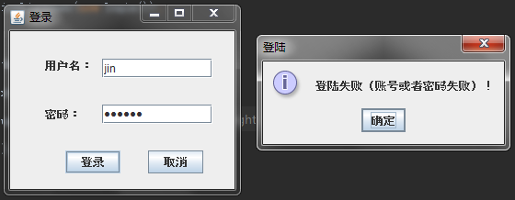

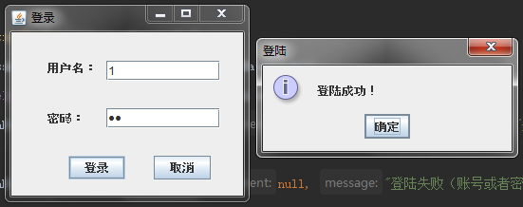

图1 第一题

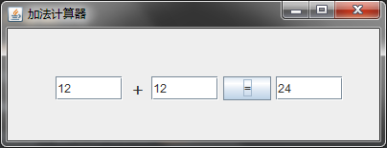

图2 第二题

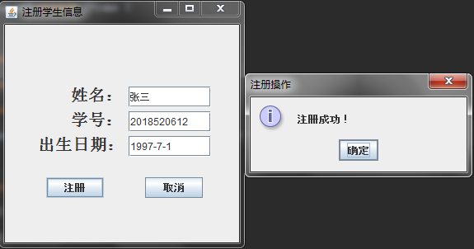

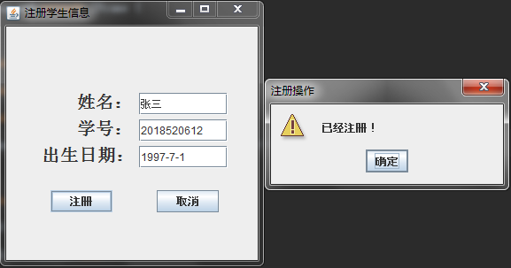

图3 第三题

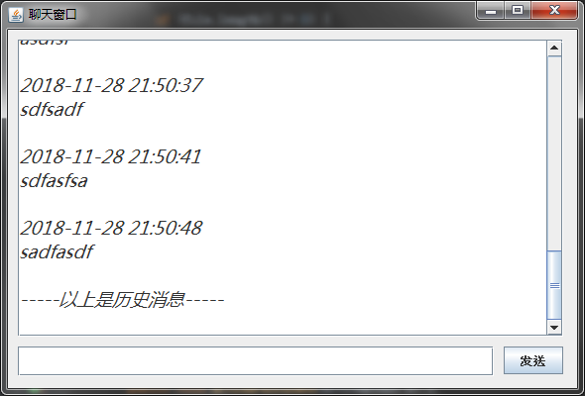

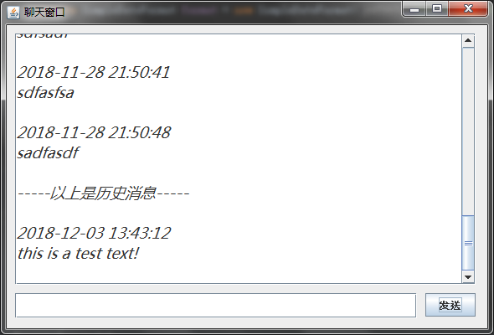

图4 第四题

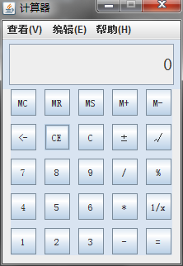

图5 第五题

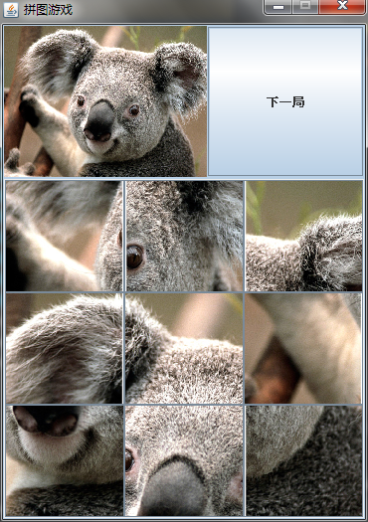

图6 第六题